1. **Wallet 3.8.1 WEB Automation Suite Guide**
2. **Version 1.0**

Table of Contents

1 Document Overview 4

1.1 About this Document 4

1.2 Intended Audience 4

2 Functional Specifications 5

2.1 Description 5

2.1.1 Modules 17

5 Disclaimer 20

Document Change History

|  |  |  |  |  |  |  |
| --- | --- | --- | --- | --- | --- | --- |
| Sr. No. | Document Version No. | Release Date | Change Description | Prepared By | Reviewed By | Approved By |
| 1 | V 1.0 |  |  | Ayush Kumar Singh |  |  |
|  |  |  |  |  |  |  |

# Document Overview

## About this Document

The document covers the usage of Wallet and WEB Framework using **Appium,** **Selenium** & **TestNG**.

## Intended Audience

This document is targeted for following audience:

* Test Engineers
* Engineering Teams
* Quality Team

# Functional Specifications

## Description

**Why Selenium?**

* **Selenium** is a set of different software tools each with a different approach to supporting test automation.
* Because of its JavaScript based automation engine and the security limitations browsers apply to JavaScript.
* **Selenium** is a free (**Open source**) automated testing suite for web applications across different browsers and platforms.
* Can run tests across **different browsers.**
* Supports **various operating systems.**
* Can execute tests **while**the **browser is minimized.**

**TestNG**

* **TestNG** is a testing framework inspired from JUnit but introducing some new functionality that make it more powerful and easier to use.
* Run Tests based on **Annotations**.
* Test that your code is multithread safe.
* Flexible test configuration.
* Support for data-driven testing (with @DataProvider).
* Support for parameters.
* Supported by a variety of tools and plug-ins (Eclipse, IDEA, Maven, etc...).
* Default JDK functions for runtime and logging (no dependencies).

**Why Appium?**

Appium is an open-source tool for automating native, mobile web, and hybrid applications on iOS mobile, Android mobile, and Windows desktop platforms. Native apps are those written using the iOS, Android, or Windows SDKs. Mobile web apps are web apps accessed using a mobile browser (Appium supports Safari on iOS and Chrome or the built-in 'Browser' app on Android). Hybrid apps have a wrapper around a "webview" -- a native control that enables interaction with web content.

Importantly, Appium is "cross-platform": it allows you to write tests against multiple platforms (iOS, Android, Windows), using the same API. This enables code reuse between iOS, Android, and Windows testsuites.

**Appium Server :**

Appium is a server written in Node.js. It can be built and installed from source or installed directly from NPM:

**SDK (Software Development Kit) :**

A software development kit (SDK) is a collection of software development tools in one installable package. They ease creation of applications by having compiler, debugger and perhaps a software framework. They are normally specific to a hardware platform and operating system combination.An SDK can take the form of an application programming interfaces (APIs) in the form of on-device libraries of reusable functions used to interface to a particular programming language, or it may be as complex as hardware-specific tools that can communicate with a particular embedded system.

**ADB :**

ADB is included in the Android SDK Platform-Tools package. You can download this package with the SDK Manager, which installs it at android_sdk/platform-tools/.

When you start an adb client, the client first checks whether there is an adb server process already running. If there isn't, it starts the server process. When the server starts, it binds to local TCP port 5037 and listens for commands sent from adb clients—all adb clients use port 5037 to communicate with the adb server.

**Tesseract:**

1. This package contains an OCR engine - libtesseract and a command line program - tesseract.

2. Tesseract has unicode (UTF-8) support, and can recognize more than 100 languages "out of the box".

3. Tesseract supports various output formats: plain text, hOCR (HTML), PDF, invisible-text-only PDF, TSV. The master branch also has experimental support for ALTO (XML) output.

4. Tesseract can be trained to recognize other languages. See Tesseract Training for more information.



**Combination of these tags are used while creating a Suite.**

### Setup Procedure

**The Procedure to Setup Automation Suite is as follows.**

**Prerequisite:- Install the listed software before the setup.**

* **Install Node JS:**
* **Download the Node Js from given Path :** [**https://nodejs.org/en/download/**](https://nodejs.org/en/download/)
* **Install Appium Through CLI :**
* **For Installing : npm install -g npm**
* **For Installing : npm install -g** [**appium@2.0.0-beta.33**](mailto:appium@2.0.0-beta.33)
* **For UIAutomator2 : appium driver install uiautomator2**
* **For Starting : appium**
* **Note : By Default it will run on : 127.0.0.1:4723**
* **Install Android Studio :**
* **https://developer.android.com/studio?gclid=Cj0KCQjw_4-SBhCgARIsAAlegrUKHwPaKl0v4Fl6Uz5uGOlX5mnEB5gYWvmN7Q0lCRF2QbbcWHnUeJYaAutdEALw_wcB&gclsrc=aw.ds**
* **Enable adb debugging on your device :**
* **To use adb with a device connected over USB, you must enable USB debugging in the device system settings, under Developer options.**
* **On Android 4.2 and higher, the Developer options screen is hidden by default. To make it visible, go to Settings > About phone and tap Build number seven times. Return to the previous screen to find Developer options at the bottom.**
* **You can now connect your device with USB. You can verify that your device is connected by executing adb devices from the android_sdk/platform-tools/ directory. If connected, you'll see the device name listed as a "device."**
* **Install Tesseract:**
* **Download and install the tesseract from given path :** [**https://github.com/tesseract-ocr/tesseract/wiki/Downloads**](https://github.com/tesseract-ocr/tesseract/wiki/Downloads)
* **Install Any IDE like IntelliJ**
* **Install JDK(1.8 minimum)**
* **Set Environment Variables as mentioned in below lines :-**
* **Vaiable Name :- ANDROID_SDK_HOME**

**Path :- C:\Users\ <username> \AppData\Local\Android\sdk**

* **Vaiable Name :- ANDROID_HOME**

**Path :- C:\Users\<username>\AppData\Local\Android\sdk**

* **Vaiable Name :- JAVA_HOME**

**Path :- C:\Program Files\Java\jdk1.8.0_171**

* **Pull the project using GIT**
* **URL:** [**http://blrgitlab.comviva.com/PVG/walletproject.git**](http://blrgitlab.comviva.com/PVG/walletproject.git)
* **After successfully importing the project , open the Project in IDE and wait until all the dependencies will not get downloaded.**

### Sequence Flow

#### Before Execution

**Mandatory Changes Required for Release**

Below are some changes which are needed for every release

**In mobile.properties**

*# HANDSET DETAILS*

**device.udid** = **ce11160b81626c3505**

*# Define the Application Package and Activity*

**app.package** = **com.batelco.sub  
app.activity** = **com.batelco.activity.Splashscreen**

*#Name of the Application*

*#No need to change when you are running the suite on e-floos/b-wallet.*

*#Need to change when you are running the suite on Muscat/OAB.***application.name** = **AFS  
project.name** = **Omantel**

*#change according to country* **application.country** = **OM**

*# E X E C U T I O N L A N G U A G E*

**language.code** = **en  
country.code** = **BH**

**Below ones are not mandatory but advised.**

*# Appium Server URL  
# Don't Change the below property unless required. default property is set***appium.server.url** = **http://0.0.0.0:4723/wd/hub**

*# HANDSET DETAILS***device.name** = **One Plus  
device.version** = **8.0.0  
device.platform** = **Android**

**In project.properties**

*#EXCEL_FILENAME_AND_SHEET_NAME***wallet.excel.filename** = **credentials.xlsx  
wallet.excel.sheetname** = **SHEET1**

#### App Data

**Mandatory Data Need to be Fill According to status and country**

**In credentials.xlsx**

|  |  |  |  |
| --- | --- | --- | --- |
| **MSISDN** | **STATUS** | **COUNTRY** | **PIN** |
| 77565681 | BL | BM | 14709 |
| 77885544 | S | BM | 25809 |
| 77123478 | Y | BM | 14709 |
| 77898944 | B | BM | 25809 |

# Extra Specifications

### Reporting

1. The Reporting feature of the Automation Suite is implemented by using **Extent Report**. The
2. Automation Suite has very good reporting, one can easily understand the Test Results by seeing the report. For each failure case there would be one Screenshot attached and also Error logs would be there.

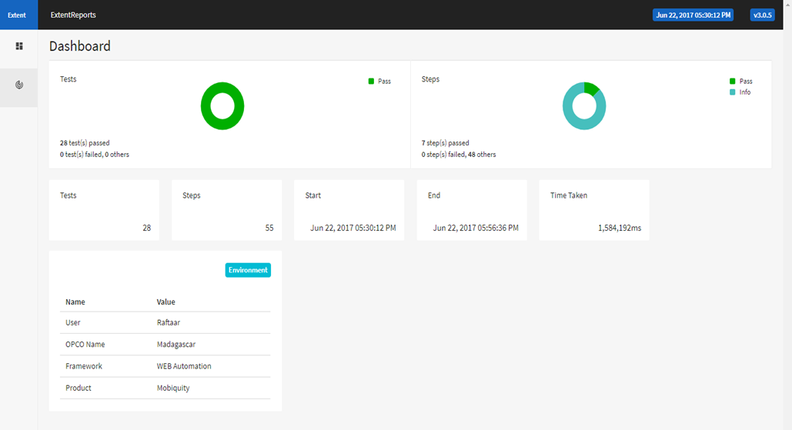

# Disclaimer

Copyright © 2013: Mahindra Comviva Technologies Ltd, Registered Office at 5th, 7th & 8th Floor, Capital Cyberscape, Golf Course Ext Rd, Sector 59, Gurugram, Haryana 122102

All rights about this document are reserved and shall not be , in whole or in part, copied, photocopied, reproduced, translated, or reduced to any manner including but not limited to electronic, mechanical, machine readable ,photographic, optic recording or otherwise without prior consent, in writing, of Mahindra Comviva Technologies Ltd (the Company).

The information in this document is subject to changes without notice. This describes only the product defined in the introduction of this documentation. This document is intended for the use of prospective customers of the Company Products Solutions and or Services for the sole purpose of the transaction for which the document is submitted. No part of it may be reproduced or transmitted in any form or manner whatsoever without the prior written permission of the company. The Customer, who/which assumes full responsibility for using the document appropriately, The Company welcomes customer comments as part of the process of continuous development and improvement.

The Company has made all reasonable efforts to ensure that the information contained in the document are adequate, sufficient and free of material errors and omissions. The Company will, if necessary, explain issues, which may not be covered by the document. However, the Company does not assume any liability of whatsoever nature , for any errors in the document except the responsibility to provide correct information when any such error is brought to company’s knowledge. The Company will not be responsible, in any event, for errors in this document or for any damages, incidental or consequential, including monetary losses that might arise from the use of this document or of the information contained in it.

This document and the Products, Solutions and Services it describes are intellectual property of the Company and/or of the respective owners thereof, whether such IPR is registered, registrable, pending for registration, applied for registration or not.

The only warranties for the Company Products, Solutions and Services are set forth in the express warranty statements accompanying its products and services. Nothing herein should be construed as constituting an additional warranty. The Company shall not be liable for technical or editorial errors or omissions contained herein.

The Company logo is a trademark of the Company. Other products, names, logos mentioned in this document, if any, may be trademarks of their respective owners.

Copyright © 2013: Mahindra Comviva Technologies Limited. All rights reserved.